

**FACULTY OF COMPUTER AND MATHEMATICAL SCIENCES**

BACHELOR OF INFORMATION TECHNOLOGY (HONS.)

**PROPOSAL**

**WADAH INFORMATION SYSTEM**

LECTURE’S NAME:

PROF DR. SHARIFAH LAILEE BT SYED ABDULLAH

**GROUP 3**

|  |
| --- |
| GROUP MEMBERS : |
| MOHD FAHMY IZWAN BIN ZULKHAFRI (2016758447)  MUHAMMAD FAZLI MIHSAH BIN MOHD FAZILAH (2016722689)  ARIFAH NAJWA BINTI MOHD LOTFI (2016734921)  NUR IZLIN BINTI ISKAK (2016709785)  NOOR AISHAH NABILA BINTI MUHAMAD NIZAM (2016701379)  NURUL SYAHIRAH SYAMIMI BINTI AZMI (2016589239)  NOR FAEZAH BINTI ABDUL RAZAK (2016559597) |
| GROUP : RCS2404A |

**SEMESTER:**

**SEPT 2018 – JAN 2018**

**TABLE OF CONTENT**

**Contents Page**

ACKNOWLEDGEMENT 1

CHAPTER 1: INTRODUCTION 2

1.1 INTRODUCTION OF THE PROJECT 2

1.2 OBJECTIVE OF THE PROJECT 2

CHAPTER 2: ORGANIZATION 3

2.1 ORGANIZATION BACKGROUND 3

2.2 THE PURPOSE OF THE ESTABLISHED 3

2.3 VISION AND MISSION 3

CHAPTER 3: SYSTEM PLANNING 4

3.1 INTRODUCTION 4

3.1.1 DESCRIPTION OF THE CURRENT/EXISTING SYSTEM 4

3.2 MAIN REASON OF THE SYSTEM PROJECT 4

3.3 FEASIBILITY STUDY 4

3.3.1 OPERATIONAL 5

3.3.2 TECHNICAL 5

3.3.3 ECONOMIC 6

3.3.4 SCHEDULE 6

CHAPTER 4 : SYSTEM ANALYSIS AND DESIGN 7

4.1 INTRODUCTION 7

4.2 SYSTEM REQUIREMENTS 7

4.2.1 SYSTEM OBJECTIVES 7

4.2.2 SYSTEM SCOPE 8

4.2.3 FUNCTIONAL REQUIREMENTS 8

4.2.4 PROCESS REQUIREMENT 8

4.2.5 SECURITY AND REQUIREMENT 9

4.3 PROCESS MODELLING 10

4.3.1 CONTEXT DIAGRAM 10

4.3.2 DATA FLOW DIAGRAM 12

4.4 DATA MODELLING 18

4.4.1 ENTITY RELATIONSHIP DIAGRAM/ERD 18

4.5 SCREEN 22

# ACKNOWLEDGEMENT

Assalamualaikum w.b.t

In preparation of our assignment, we had to take the help and guidance of some respected persons, who deserve our deepest gratitude. As the completion of this assignment gave us much pleasure, we would like to show my gratitude Dr. Sharifah Nurlailee, Course Instructor, on Universiti Teknologi Mara Perlis Branch for giving us a good guidelines for assignment throughout numerous consultations. We would also like to expand my gratitude to all those who have directly and indirectly guided us in writing this assignment.

In addition, we would like to give our heartfelt thanks to our teammate for contributing a huge amount of help and having a great sense of teamwork during the period of doing this project until we are able to finish WADAH Information System in the time given to us.

Next, also would like give a big thank you to our classmates have given valuable comment suggestions on our paper work which gave us an inspiration to improve the quality of the assignment.

Last but not least, let us not to forget to give our special thanks to our beloved parents who have been giving us moral support along with financial support for us to be able to complete this project successfully.

# CHAPTER 1: INTRODUCTION

This chapter explains about WADAH Kedah information system and its objectives.

## 1.1 INTRODUCTION OF THE PROJECT

The purpose of creating this information system is to make works for both admin and staff is easier and the member can check the activities they have attend that organize by the WADAH Kedah since they doesn’t have their own information system.

## 1.2 OBJECTIVE OF THE PROJECT

The reason why we created the WADAH Information System is to track all activities that held surrounding the members and the admin can easily key-in the account that came in and out. Before this, WADAH Kedah is lack in their performance to track all the activities and information about members and events, so we hope after we implement this system WADAH Kedah works will become easier.

# CHAPTER 2: ORGANIZATION

## 2.1 ORGANIZATION BACKGROUND

The establishment of the WADAH is to empower Muslims through efforts to increase the knowledge, intelligence and force think them, especially in understanding Islam as well as in issues important to the question faced by the community.

Wadah Pencerdasan Umat Malaysia was registered as a legitimate organization on 9 November 2005 with the registration 1947-05-7 (Selangor). Most of the members of the WADAH are ex-members of Angkatan Belia Islam Malaysia (ABIM). However, membership of the WADAH are open to Malaysian Muslim and aged 35 years or older, regardless of race, ethnicity and gender.

## 2.2 THE PURPOSE OF THE ESTABLISHED

* Implement the missionary programs and social awareness to increase awareness and sense of responsibility towards religion, race and country.
* Exercise training to produce an efficient speaker.
* Educate the generations through the efforts of wide spread views and stance on various issues arising on the basis of an Islamic perspective through a variety of channels and media available.

## 2.3 VISION AND MISSION

VISION

Empowerment people credible and competent on the basis of indicators based on al-Kitab and al-Hikmah.

MISSION

Empowering generations by means of raising awareness and intelligence force thought them through expansion of quality literature, debate and discourse of knowledge and quality statement clear and firm views.

# CHAPTER 3: SYSTEM PLANNING

## 3.1 INTRODUCTION

* Agrees with our lecturer to develop system requirements for organization WADAH.
* Management authorization of organization WADAH to continue is obtained.

### 3.1.1 DESCRIPTION OF THE CURRENT/EXISTING SYSTEM

* The official system of WADAH does not exist.
* There is no official system to give information about WADAH’s feedbacks from users.
* The community does not know about the existence of WADAH.

## 3.2 MAIN REASON OF THE SYSTEM PROJECT

* To create a proper information system for WADAH.
* To ease users’ works to find information of WADAH’s activities.
* To ease members or the public to donate and give suggestions to improve WADAH.
* To organize WADAH’s activities properly.

## 3.3 FEASIBILITY STUDY

This system is entitling as "WADAH feedback". The system is to collect data of member's suggestions of next activities, give feedbacks of past activities for improvements, and showcase articles written about WADAH. For example, if users are interested in joining WADAH, they can easily surf the website to get the general ideas of how WADAH operate. Besides that, this system also eases users to donate for WADAH and for admin to keep up with the use of donations.

In conclusion, this system will be easy and time saving for users and admins to improve WADAH.

### 3.3.1 OPERATIONAL

* The new system will contribute to reduction in workforce. This will allow the admin to use this system with ease.
* The new system does not require training or a manual for the users to use it. This is because the system is user friendly and users of all age can easily use it without trouble.
* This system will need new demands because day by day people change their tastes so this system will be changed to accommodate to the people’s demands.
* The admin maybe will experience adverse effects temporarily.
* It might probably not give any risk towards the organization image.
* The developments schedule does not conflict with other organizations priorities.

### 3.3.2 TECHNICAL

* The organization does not have the necessary hardware, software and network resources
* The organization also do not have the needed technical expertise.
* The proposed platform have sufficient capacity for future needs.
* The prototype is required for this project.
* The combination of hardware and software supply need for adequate performance.
* The system will be able to handle future transaction volume and organization growth.

### 3.3.3 ECONOMIC

* Cost for IT admin.
* Cost for hardware and equipment.
* Cost of licenses and fees.
* Cost of activity expenses.
* Facility costs.
* The estimated cost of not developing the system the project is more.

### 3.3.4 SCHEDULE

* The IT admin can control the factors that affect schedule feasibility.
* The IT developer have established a firm timetable for this project.
* The condition that have been use for satisfied during the development of the system is, it is can ease the admin and member for using this project.

# CHAPTER 4 : SYSTEM ANALYSIS AND DESIGN

## 4.1 INTRODUCTION

Research method generally is a guideline used to solve problems which consists of several components such as methods, phases, techniques and tools. There are a lot of advantages having a research method as it will provide a framework to plan, review and control for system that will be developed.

## 4.2 SYSTEM REQUIREMENTS

In this phase, requirements such as function needed for the system was determined. Requirement that the system is going to fulfill is detailed in this stage like number of level of admin and user in the system, their main functions as well as input and outcome of the system. The input is the requirements itself whereas the output is a functional specification document that will explain the system as a whole. Therefore, for WADAH Information System, there are two levels of users which are for the admin and WADAH members.

For the system, the main requirement is users have to give their information to admin for admin that want to add member of detail, is that they must be able to update the information, add new information and also it can search the existing member.

### 4.2.1 SYSTEM OBJECTIVES

The system is developed to help the admin to key in all the details and also keep track on the member of WADAH then the system also helps to track the existing member. It also allows the admin to save more time to search name by name to find the existing member of WADAH.

Besides, it also will able to make it easier for member to easily keep on track with WADAH’s upcoming activities. As member fills in and joined a certain activity, they will be able to check and look at their joined activity progress by using this system. This system will surely be a lot easier rather on not having it.

Both the members and the IT admin would be able to keep up with everything related to WADAH Organization’s information and activities.

### 4.2.2 SYSTEM SCOPE

For this system, we have decided to use a web browser as the interface for end-user. This will make it easy for admin to go online on the web provided for WADAH’s administrator/staff and member. It’s just a click away.

Next, as for the database, we have decided to use MySQL. All the details on the admin, members and members’ actvities will be kept in here. We decided to use MySQL as our database because it is user friendly and it is widely known as a popular choice of database for web applications.

PHP is known as a popular scripting language that is used for web development. We decided to use it to code our program alongside HTML. PHP code is usually combine with HTML to produce a well-developed website.

### 4.2.3 FUNCTIONAL REQUIREMENTS

The system has their function for helping the admin for ease the process of fill the information. It requires input from member for admin to key-in the information because some member from WADAH lack of IT skill so it will cause some problem for WADAH to fill it. So through this way it will help them to give right information and fill the right information.

### 4.2.4 PROCESS REQUIREMENT

The member information system must be make sure all the member fill till the end of year. As the final step in year-end processing, the system must show all the information that admin have been fill especially the information that have been update. The admin must create the pattern of form for member to fill in.

### 4.2.5 SECURITY AND REQUIREMENT

* The admin need to log in to get access when he or she wants to fill the member information to secure the member private details. The system will show error when the update member information is not in complete information as it to make sure it will misinformation to the members.
* The members will also need to log in to be able to join an activity and see their personal details. This will prevent outsiders to access and see through their personal details that supposed to be confidential and private. If the login information entered is wrong the system will give an error saying the information is not correct and the user will not be able to access the member’s profile.

## 4.3 PROCESS MODELLING

### 4.3.1 CONTEXT DIAGRAM

WADAH SYSTEM

MEMBER

ADMIN/STAFF

View activity

View activity information

Member join activity

Update and register information

Key in information

Wadah Info System

Account

Member

Member

Activities

Maintenance

Rent

Asset

Public

Costing

Family

Personal Info

Activities

### 4.3.2 DATA FLOW DIAGRAM

Scope : Members (admin)

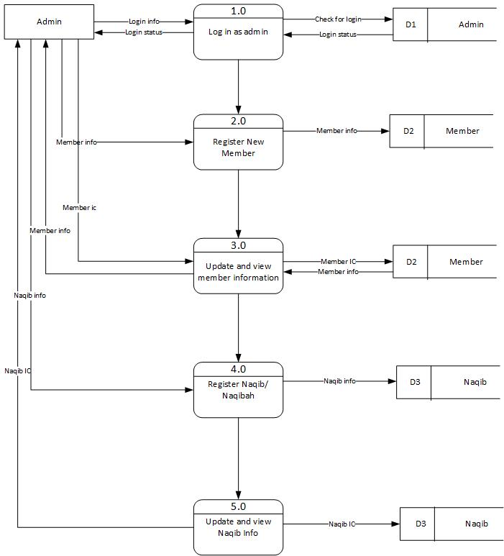

Scope : Members (member)

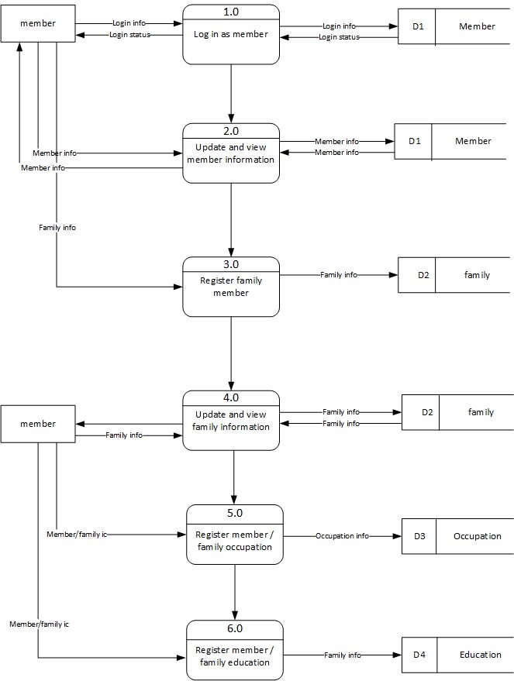

Scope : Activity

Activity info

Activity info

D1

Committee members

Activity

1.0

Register New Activity

Naqib/Naqibah info

2.0

D2

Naqib/Naqibah

Feedback info

Feedback

Member

Public

D4

D3

Activity

D1

Speaker

View Feedback

6.0

5.0

View List Activity

4.0

Assign Speaker

3.0

Assign Naqib/Naqibah

Speaker info

7.0

Generate Report

Public

Record Feedback Event

Committee members

Activity

D1

Scope : Account

Expenses information

|  |  |
| --- | --- |
| D1 | Information |

|  |  |
| --- | --- |
| D2 | Payment |

|  |  |
| --- | --- |
| D3 | Costing |

|  |  |
| --- | --- |
| D4 | Sponsor |

|  |  |
| --- | --- |
| D3 | Costing |

|  |  |
| --- | --- |
| D3 | Costing |

Outstanding Information

Cost activity information

Sponsorship information

Sponsorship information

Cost activity

Member’s fee information

Member’s fee information

Fee

Expenses information

Admin

Member

Admin

Member

Admin

6.0

Calculate cost

5.0

Register sponsorship

4.0

Register activity cost

3.0

Update member’s fee

2.0

Register member’s fee

1.0

Record new expenses

|  |  |
| --- | --- |
| D2 | Payment |

Outstanding Information

Outstanding Information

Cost activity information

Cost activity information

Sponsorship information

Sponsorship information

Cost activity information

7.0

Calculate outstanding balance

Member’s fee information

Member’s fee information

Member’s fee information

Scope : Asset

1.0

Asset Info

Asset Info

D1

Asset

Admin

Register Asset

Asset Info

Asset Info

Admin

2.0

D1

Asset

View Asset

Asset Info

3.0

Chosen Info

Member

Make Chosen

Asset

Select Asset

D1

4.0

Booking Asset

Rental Info

D2

Rental asset

Reserve Asset

Member

5.0

Deposit Info

Deposit info

D2

Rental asset

Record Deposit

Rental Info

Rental Info

6.0

D2

Rental asset

View Rental Asset

Rental Info

Company Info

Admin

Company Info

Rental asset

7.0

D2

View Company

Generate Yearly Rent

8.0

Yearly Rental Info

Yearly Rental Info

D2

Rental asset

Maintenance Information

List Maintenance Record

4.0

Admin

3.0

Update Maintenance Record

Admin

View Asset Status

2.0

Register Asset

1.0

Admin

Admin

Maintenance

Maintenance

Asset

Asset

Asset Information

Asset Information

D2

Maintenance Record

Maintenance Record

D2

Maintenance Information

D1

Asset Status

Asset Status

D1

## 4.4 DATA MODELLING

### 4.4.1 ENTITY RELATIONSHIP DIAGRAM/ERD

Scope : Members

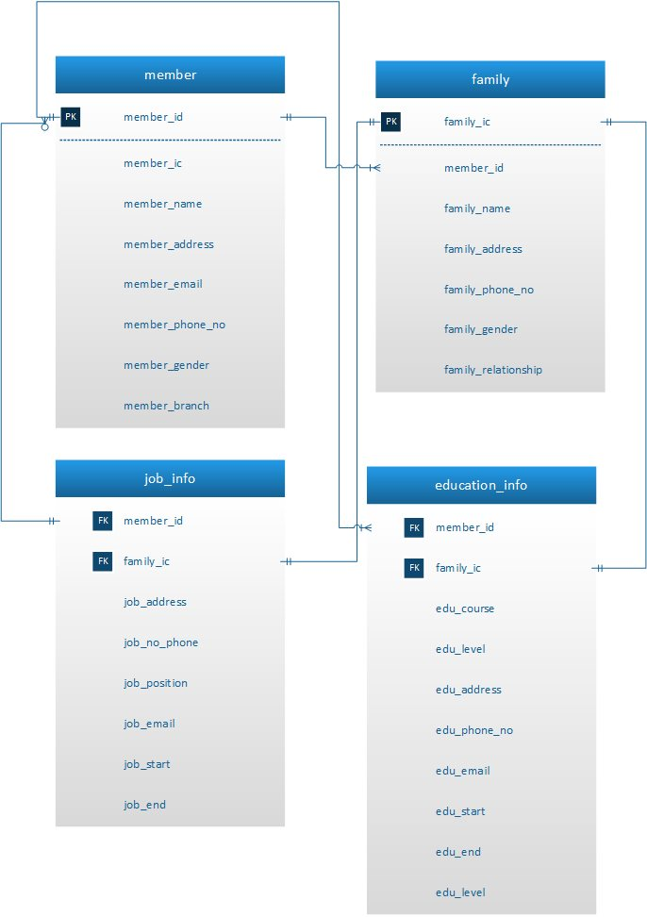

Scope : Activity

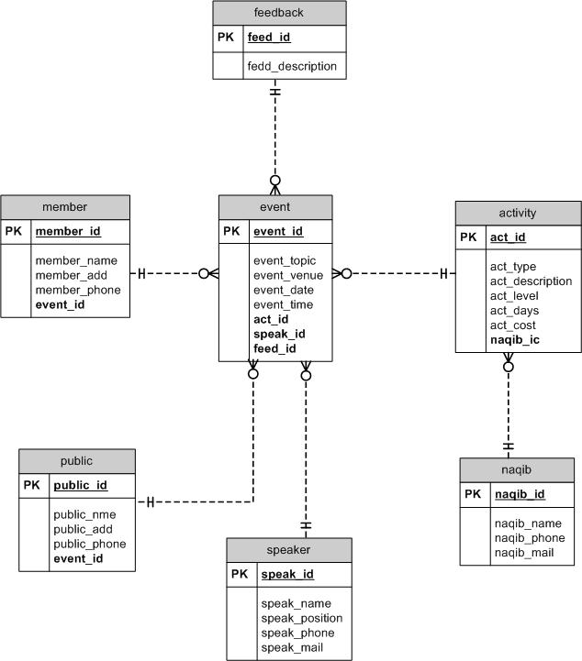

Scope : Account

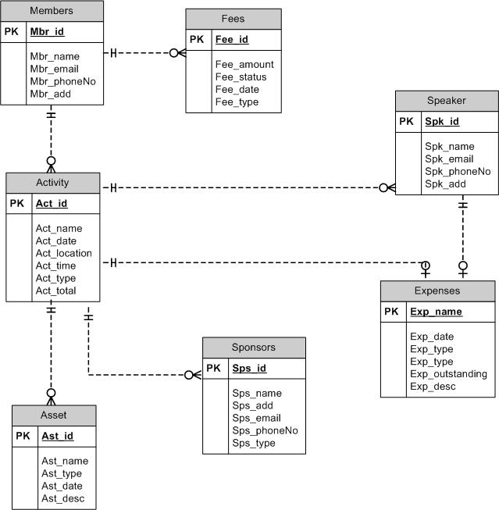

Scope : Asset

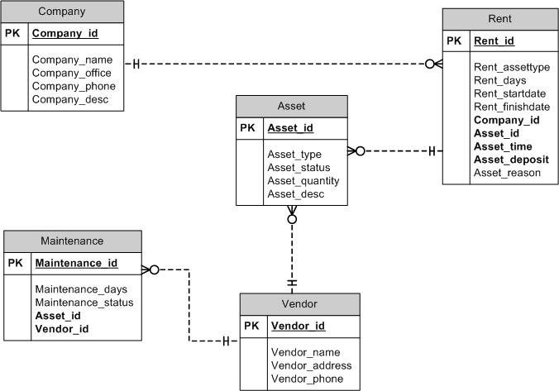

# 4.5 SCREEN

**Scope : Members**

Problem Statements :

1. Current system of Wadah need to check members information manually and its take much more time to check it through file base system and its will be more problem if the information from other branches.
2. Wadah hard to know how many children currently studying or working in same NGO.
3. The current system of wadah is not showing when the family have changes the place or change the job. Therefore, member also hard to update their information if their have change their job or school.

Questions :

1. List all wadah in every branch.
2. Number of children studying or working in same NGO
3. Able to identify the date when members were in difference branches

Objective :

1. Show all members of wadah that have been register according to branch.
2. To show all of family information of members’ in Wadah including education and occupation.

Input Screen :

|  |  |
| --- | --- |
| MEMBER INFORMATION | |
| Select Image | |
| Name : |  |
| IC Number : |  |
| Address : |  |
| Contact Number : |  |
| Gender : | - Please Select - |
| Email : |  |
| Date Of Birth : | dd /mm / yyyy |
| Branch : | - Please Select - |
| Member Fee : |  |
| Password (default) | ***** |
| Register | |

**Member Info Input Screen**

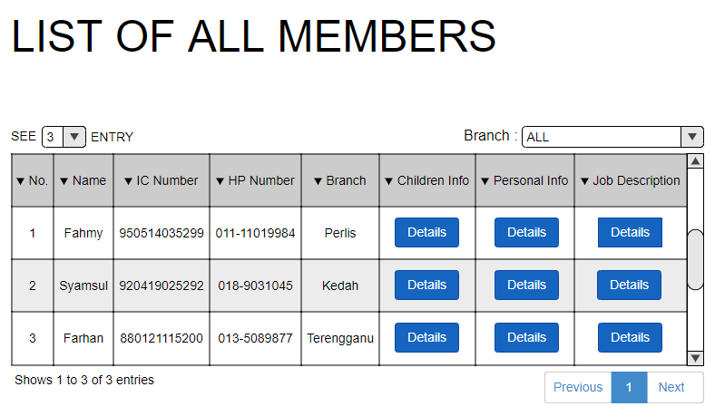**Output Screen**

**Family Info Input Screen**

|  |  |
| --- | --- |
| FAMILY INFORMATION | |
| Name : |  |
| IC Number : |  |
| Address : |  |
| Contact Number : |  |
| Gender : | - Please Select - |
| Email : |  |
| Date Of Birth : | dd /mm / yyyy |
| Relation : | - Please Select - |
| Register | |

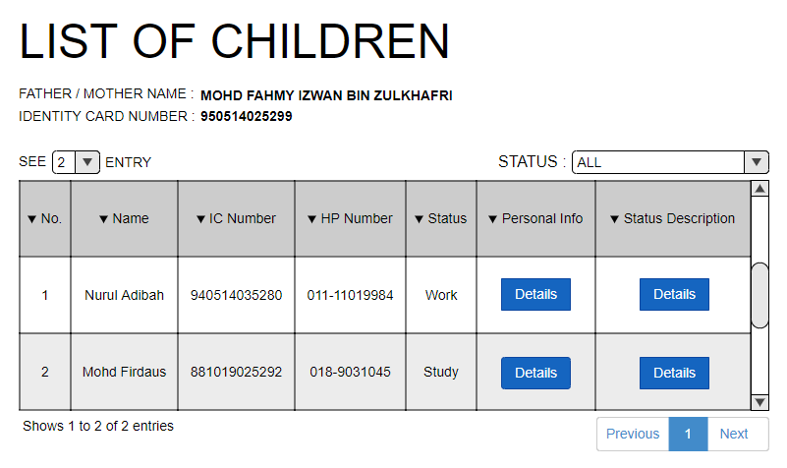**Output Screen**

**Occupation Info Input Screen**

|  |  |
| --- | --- |
| OCCUPATION INFORMATION | |
| Company Name : |  |
| Company Address : |  |
| Company Phone : |  |
| Email : |  |
| Position : |  |
| Start Date : | dd /mm / yyyy |
| End Date : | dd /mm / yyyy |
| Register | |

**Output Screen**

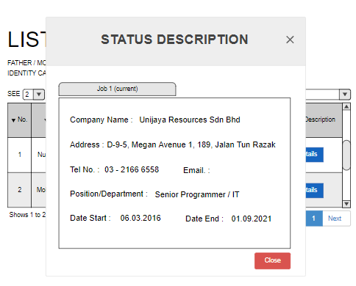

**Education info Input Screen**

|  |  |
| --- | --- |
| EDUCATION INFORMATION | |
| Name : |  |
| Address : |  |
| Phone |  |
| Level : | - Please Select - |
| Start Study : | dd /mm / yyyy |
| Graduation Date : | dd /mm / yyyy |
| Register | |

**Output Screen**

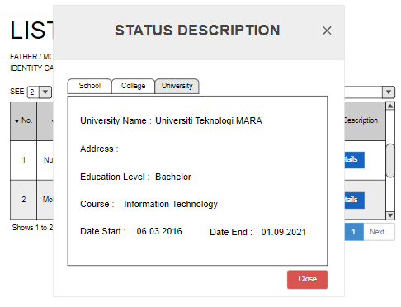

**Scope : Activity Member**

Problem Statements :

1. Unable to check the activities that joined by the members due to many activities and the organization doesn’t know did members join the activities or not.
2. After joining the activities, the organization doesn’t know did the members get the impact from what they attend. Then, they did the survey from the activity.

Questions :

1. List of activities that the members join.
2. Did the members join the activity?
3. How many members are present?
4. List of impact of the activity on the members.

Objective :

1. To list all the activities that the members join based on date, venue and event. That will list all the details about the activity.
2. To list all the impact that the members get from joining the activities that held by the organization and the organization will make a survey from the impact that members give.

Input Screen :

1. List of activities followed by members and how many members are present

Activity

All Activity

Year

ic

All Year

**Search**

Output Screen :

|  |  |  |  |  |  |
| --- | --- | --- | --- | --- | --- |
| **Activity** | **Date** | **Venue** | **Members** | **Total Members Present** |  |
| Muktamar | 2/3/2018 | Sg. Petani | 1. Azlan bin Aziz 2. Abu Rahman bin Ali Rahman 3. Osman bin Sukri 4. Khalil bin Ahmad 5. Siti binti Abdullah 6. Fatimah binti Rahmat 7. Kasim bin Abdul 8. Zainab binti Johari 9. Zaleha binti Johari 10. Zaiton binti Johari 11. Zailan bin Kadir 12. Zakaria bin Aman 13. Nazzri bin Ali 14. Ramli bin Jalil 15. Amirah binti Amran | **15** | Details |
| Usrah Minggu-2 | 6/3/2018 | Masjid An-Nur | 1. Zainab binti Johari 2. Zaleha binti Johari 3. Zaiton binti Johari 4. Zailan bin Kadir 5. Zakaria bin Aman 6. Nazzri bin Ali 7. Ramli bin Jalil 8. Amirah binti Amran | **8** | Details |
| Tamrin | 10/4/2018 | Arau | 1. Azlan bin Aziz 2. Abu Rahman bin Ali Rahman 3. Osman bin Sukri 4. Khalil bin Ahmad 5. Siti binti Abdullah 6. Fatimah binti Rahmat | **6** | Details |

Input Screen :

2. Did the members follow the activity?

Please enter IC number :

SEARCH

Output Screen :

**Muhammad Iqbal bin Iskak**

**Ahli Tetap**

**PT 45642 , Kg Sg. Balak, Kajang, Selangor**

**017-2433058**

|  |  |  |  |
| --- | --- | --- | --- |
| No. | Activities | Date | Venue |
| 1. | Usrah Minggu ke-6 | 11/2/2017 | Arau |
| 2. | Usrah Minggu ke-7 | 18/3/2017 | Jitra |
| 3. | Usrah Minggu ke-11 | 12/4/2017 | Sg. Petani |
| 4. | Tamrin | 19/4/2017 | Arau |
| 5. | Muktamar | 20/8/2017 | Kuala Lumpur |

Input Screen :

1. List of impact of the activity on the member

Survey

1 : Very disagree 2 : Disagree 3 : Maybe 4 : Agree 5 : Very Agree

5

4

3

2

1

|  |  |  |  |  |  |
| --- | --- | --- | --- | --- | --- |
| I get information after joining this activities. |  |  |  |  |  |
| I was able to recognize new friends after participating in this activity |  |  |  |  |  |
| The equipment used is very good |  |  |  |  |  |
| Food is provided to taste and clean |  |  |  |  |  |
| The venue was very comfortable |  |  |  |  |  |

Output Screen :

**ANALYSIS FROM FEEDBACK**

Question 1 : I get information after joining this activities.

* Very Agree (30.00 %)
* Agree (60.00 %)
* Maybe (10.00 %)
* Disagree (0 %)
* Very Disagree (0 %)

Question 2 : I was able to recognize new friends after participating in this activity.

* Very Agree (40.00 %)
* Agree (50.00 %)
* Maybe (10.00 %)
* Disagree (0 %)
* Very Disagree (0 %)

Question 3 : The equipment used is very good.

* Very Agree (100.00 %)
* Agree (0 %)
* Maybe (0 %)
* Disagree (0 %)
* Very Disagree (0 %)

Question 4 : Food is provided to taste and clean.

* Very Agree (40.00 %)
* Agree (30.00 %)
* Maybe (30.00 %)
* Disagree (0 %)
* Very Disagree (0 %)

**Scope: Account**

Problem Statement: The organization had conducted many activities and events so they must have cost expanding of money for each activity. But there aren’t correctly listed in the bill. Furthermore, they received a lot of sponsorships for each event too but they don’t have a proper record for it. Therefore, they need well-formatted information for the sponsorship given and list of bill.

Question: List the expenses for accomplishing for certain activity and the sponsorship for the program.

Objective: To show a list of cost for each activities and sponsorship in every events.

Input Screen:

|  |  |  |  |  |  |  |  |
| --- | --- | --- | --- | --- | --- | --- | --- |
| |  |  |  | | --- | --- | --- | | MONTH: | |  | | --- | | SEPTEMBER | | |  |  | | OPTION: |  |   ENTER |

Output Screen:

|  |  |  |  |
| --- | --- | --- | --- |
| No | Activities | Venue | Expenses (RM) |
| 1 | Ceramah Awal Muharam | Dewan 2020 | 1000 |
| 2 | Bantuan kepada ibu tunggal | Dewan Harumanis, PTSS | 5000 |
| 3 | Usrah | Surau Perdana | - |

MONTH:

SEPTEMBER

3

Display:

Sponsorship:

Qariah Masjid Alwi

List of Activities:

**Scope : Account**

Problem Statement: Since in every event have lot of participant involved the organization need to find different between cost and participant. But the organization seems lost track of it.

Question: What is the relationship between cost activity and the number of participants?

Objective: To develop user friendly system that user can easily find the different between cost and participants.

Input Screen:

|  |  |  |
| --- | --- | --- |
| ENTER   |  |  | | --- | --- | | Activity: |  | |

|  |  |  |  |  |  |  |  |  |  |  |  |  |  |  |  |  |  |  |  |  |  |  |  |  |  |  |  |  |  |  |  |  |  |  |  |  |  |  |  |  |  |  |  |  |  |
| --- | --- | --- | --- | --- | --- | --- | --- | --- | --- | --- | --- | --- | --- | --- | --- | --- | --- | --- | --- | --- | --- | --- | --- | --- | --- | --- | --- | --- | --- | --- | --- | --- | --- | --- | --- | --- | --- | --- | --- | --- | --- | --- | --- | --- | --- |
| |  |  |  |  |  | | --- | --- | --- | --- | --- | | NO | NAME | IC | NO PHONE | Status | | 01 | ARIFAH NAJWA | 850625075538 | 0112446589 | Attend | | 02 | IZLIN | 900214142589 | 0168549566 | Unattend | | 03 | SYAMIMI | 880101030258 | 0138809901 | Unattend | | | | | | | | | |  | | | | | | | | | |  | | | | | | | | | |  | | | | | | | | | |  | | 100 | FAZLI | 600205102546 | 01110102345 | Attend |   BACK  Total participant is 80 people  Total cost for 80 people: RM 400  Estimated cost for 100 people: RM 500  **LIST OF MEMBERS:** |

Output Screen:

**Scope : Account**

Problem Statement: After the expenditure has been done, mostly there are balance and different between the sponsorship and cost. Hence, the balance must be reported.

Question: What the outstanding balance between sponsorship and costs

Objective: To track the outstanding balance between sponsorship and cost

Input Screen:

Date:

28/9/2018

Activities:

Berjaya Maju Enterprise

Sponsorship:

ENTER

Output Screen:

Outstanding Balance Details

28/9/2018

Date:

Ceramah Awal Muharam

Activities:

Berjaya Maju Enterprise

Sponsorship:

Cost:

|  |  |  |
| --- | --- | --- |
| No | Items | Cost (RM) |
| 1 | Motivator /Speaker | 2000 |
| 2 | Audio system rent | 200 |
| 3 | Food for VIP | 150 |
| Total: 2350 | | |

Outstanding Balance : RM 650

**Scope: Account**

Problem Statement: The organization have lots of members and participants registered, they must pay for the fees. For record and to prevent redundancy, the organization needs system to manage it.

Question: List of member’s fee information

Objective: To discover the information of member’s fee

Input screen:

August

Month:

Bantuan kepada Ibu Tunggal

Activities:



Output Screen:

|  |  |  |  |  |
| --- | --- | --- | --- | --- |
| No | IC No | Name | Payment | Details |
| 1 | 951298736523 | Faezah | Paid | View |
| 2 | 961234589182 | Aishah | Unpaid | - |
|  |  |  |  |  |
|  |  |  |  |  |
|  |  |  |  |  |
|  |  |  |  |  |

Receipt

Name: Nor Faezah Binti Abdul Razak

IC: 951238392723

Date: 3/8/2018

Payment Method: Online Banking

Fee: RM20

**Scope : Asset**

Input Screen:

Wadah Asset

Type:

**Status**

Rent

Maintenance

Asset Id:

Asset Condition:

Very good

Good

Moderate

Bad

Very bad

Asset Quantity:

1

2

3

4

5

Asset Place:

Asset Description:

Output Screen :

Wadah Asset

Type:

Microphone

**Status**

Rent

Maintenance

|  |  |  |  |  |
| --- | --- | --- | --- | --- |
| No | Asset Id | Asset Condition | Asset Place | Description |
| 1 | AST201701 | Good | Hall 9 |  |
| 2 | AST201705 | Bad | Meeting Room |  |
| 3 | AST201809 | Very Good | Store |  |

Input Screen:

Wadah Asset

Type:

**Rent**

Status

Maintenance

Asset Id:

Asset Availability:

Yes

No

Rental Days:

1

2

3

4

5

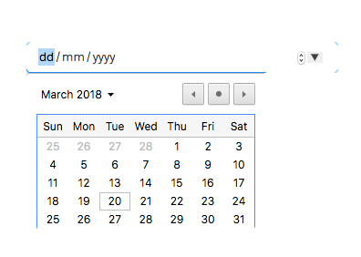

Rental Date:

Rental Company:

Output Screen :

Wadah Asset

Electronic

Type:

**Rent**

Status

Maintenance

|  |  |  |  |  |  |
| --- | --- | --- | --- | --- | --- |
| No | Asset Id | Asset Availability | Rental Days | Rental Date | Rental Company |
| 1 | AST201701 | No | 3 | 20/10/2018 –  23/10/2018 | ASV Solution Ent. |
| 2 | AST201705 | Yes |  |  |  |
| 3 | AST201809 | Yes |  |  |  |

Yearly rental record

Input Screen :

Wadah Asset

Type :

Asset ID :

**Maintenance**

Status

Rent

Maintenance Id:

Maintenance vendor:

Maintenance Progress :

100%

80%

60%

40%

20%

Maintenance Cost :

Maintenance Place :



Maintenance Date :

Maintenance Description :

Output Screen :

Wadah Asset

Hall 9

Type :

H209

Asset ID :

**Maintenance**

Status

Rent

|  |  |  |  |  |  |
| --- | --- | --- | --- | --- | --- |
| No | Maintenance Id | Vendor | Progress | Date | Description |
| 1 | Dk20001 | Cleaning Services Sdn Bhd | 100% | 02/11/2018 |  |
| 2 | Mn20055 | Repairing Ent. | 60% | 30/08/2018 |  |
| 3 | Dk10922 | Cleaning Services Sdn Bhd | 50% | 10/05/2018 |  |
| 4 | Dk10532 | Cleaning Services Sdn Bhd | 100% | 07/03/2017 |  |